**CLOUD COMPUTING**

**SUBMITTED BY:** ARMEEN ABID **(BSE-011)**

**SUBMITTED TO:** ENGR.MUHAMMAD SHOAIB

**LAB 02**

**TASK 1**

**Install Git on your PC**

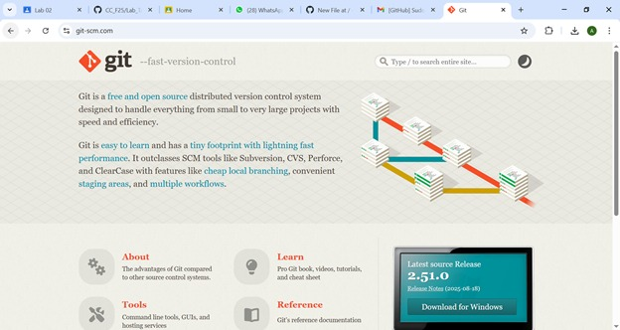

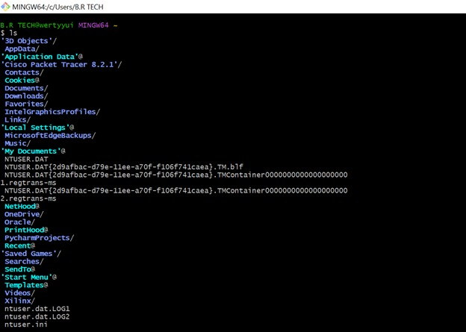

**Create Private GitHub Repository**

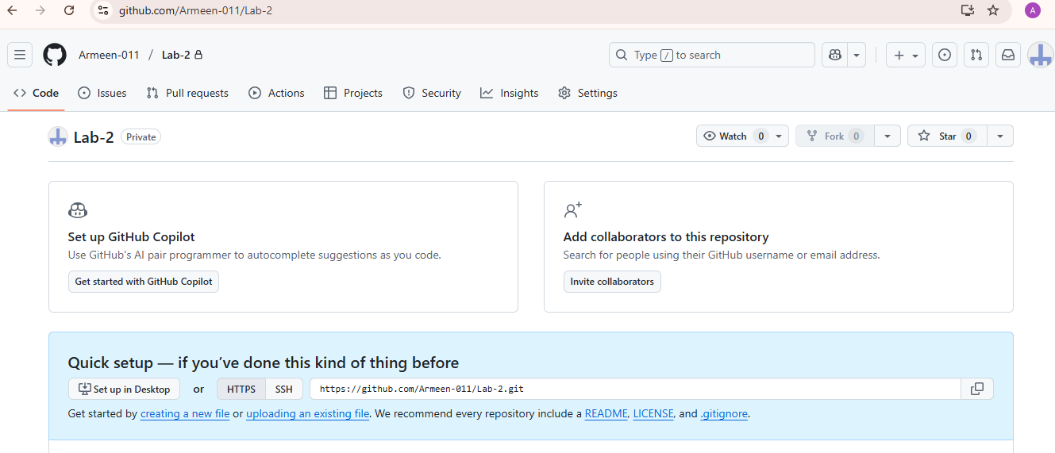

**TASK 2**

**Connect Repository via SSH**

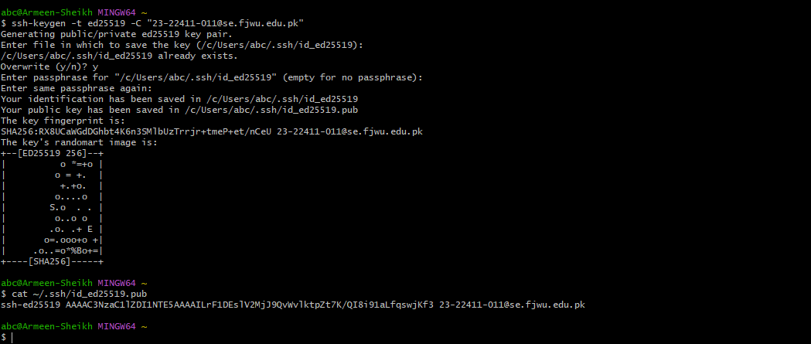

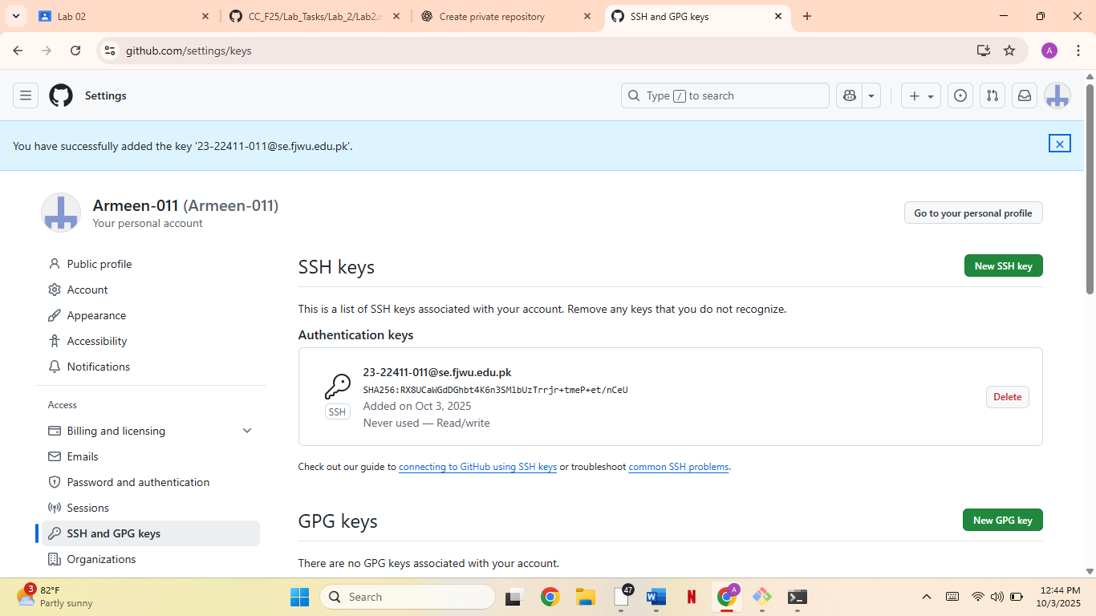

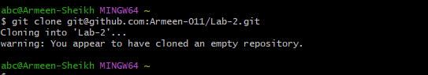

**TASK 3**

**Configure Git Username and Email**

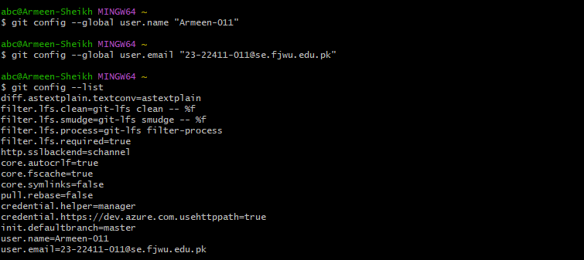

**TASK 4**

**Explore the .git Folder**

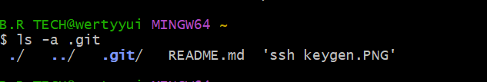

**TASK 5**

**Local Repository Management**

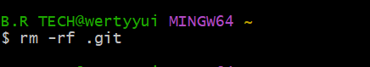

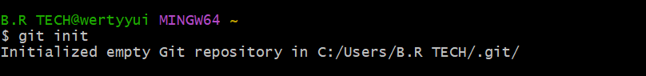

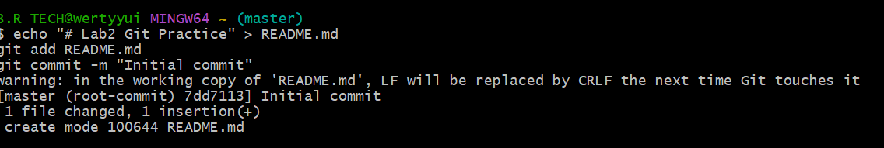

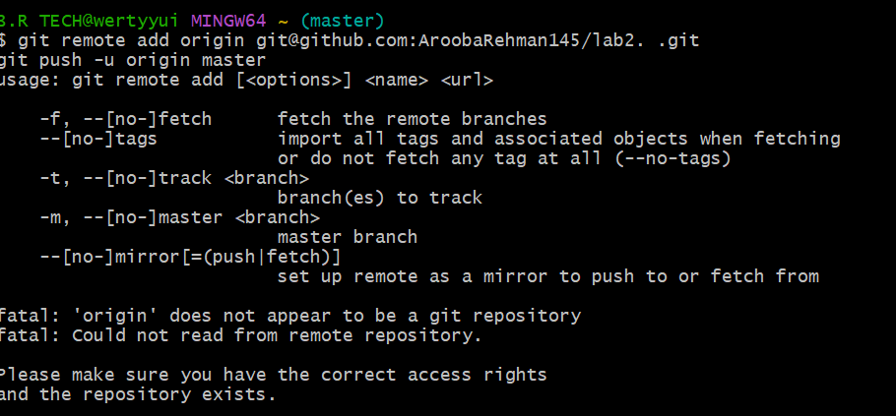

**TASK 6**

**File Status & Staging**

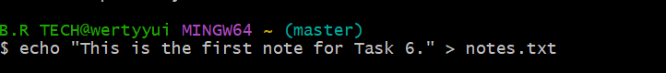

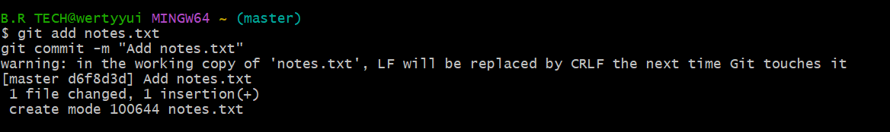

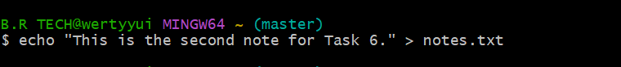

**Task 7**

**Branch Creation Using GitHub GUI**

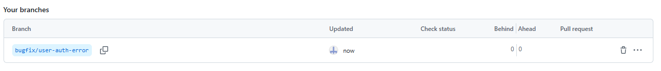

**Task 8**

**Branch Creation and Push Using Git Bash**

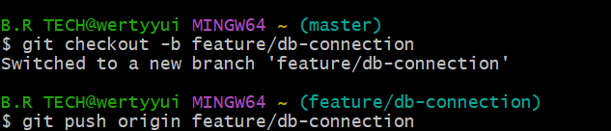

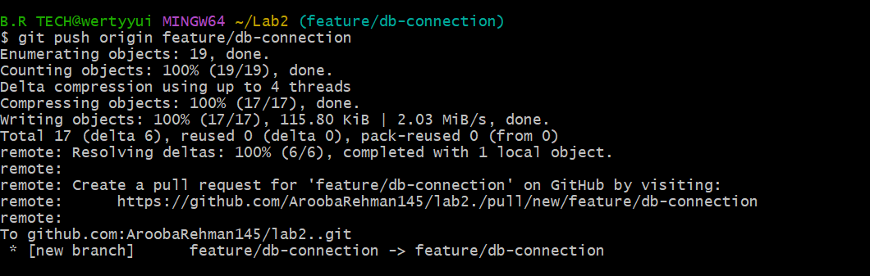

**Task 9**

**Branching & Merging**

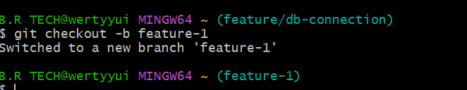

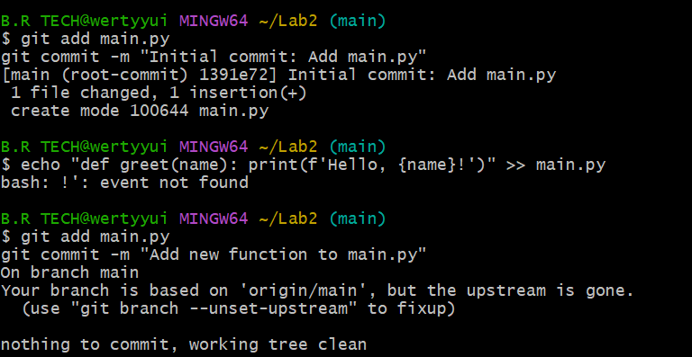

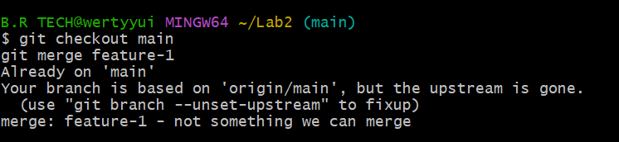

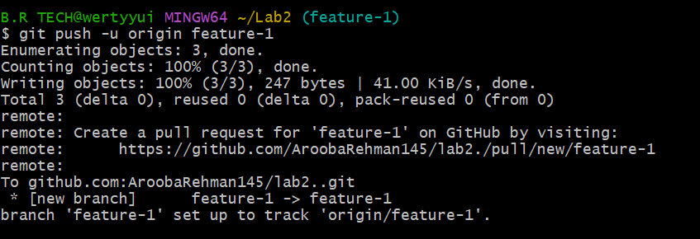

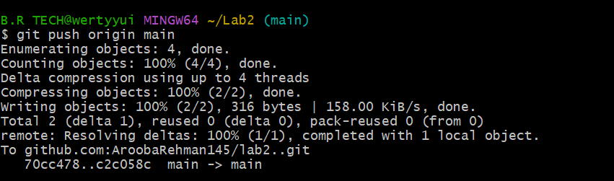

**Task 10**

**Pull Request and Branch Review**

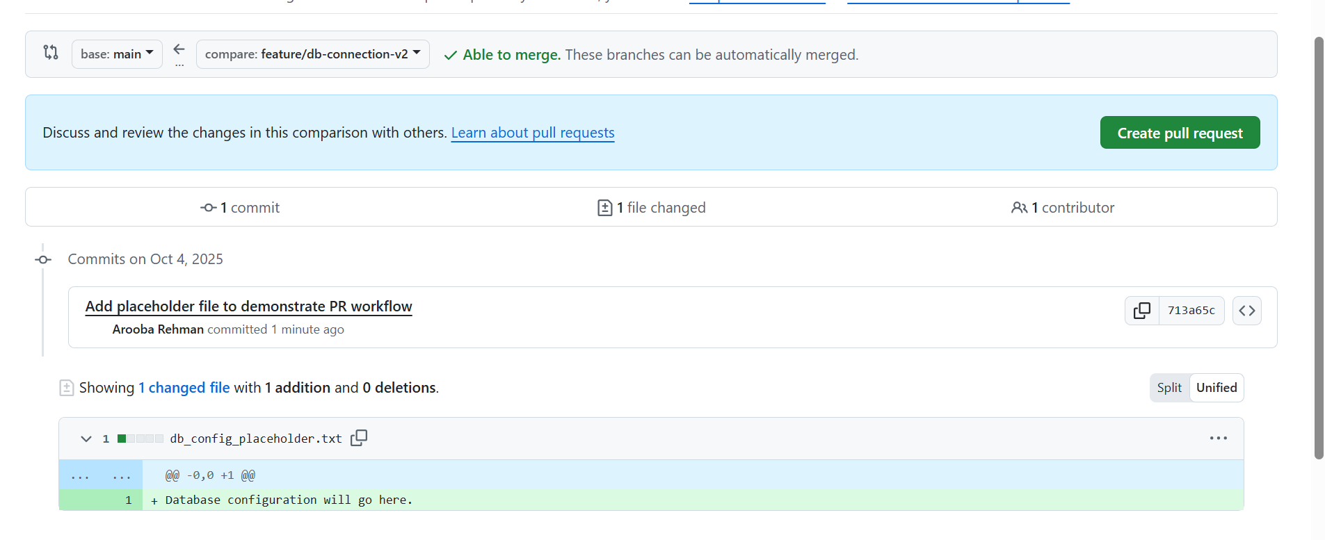

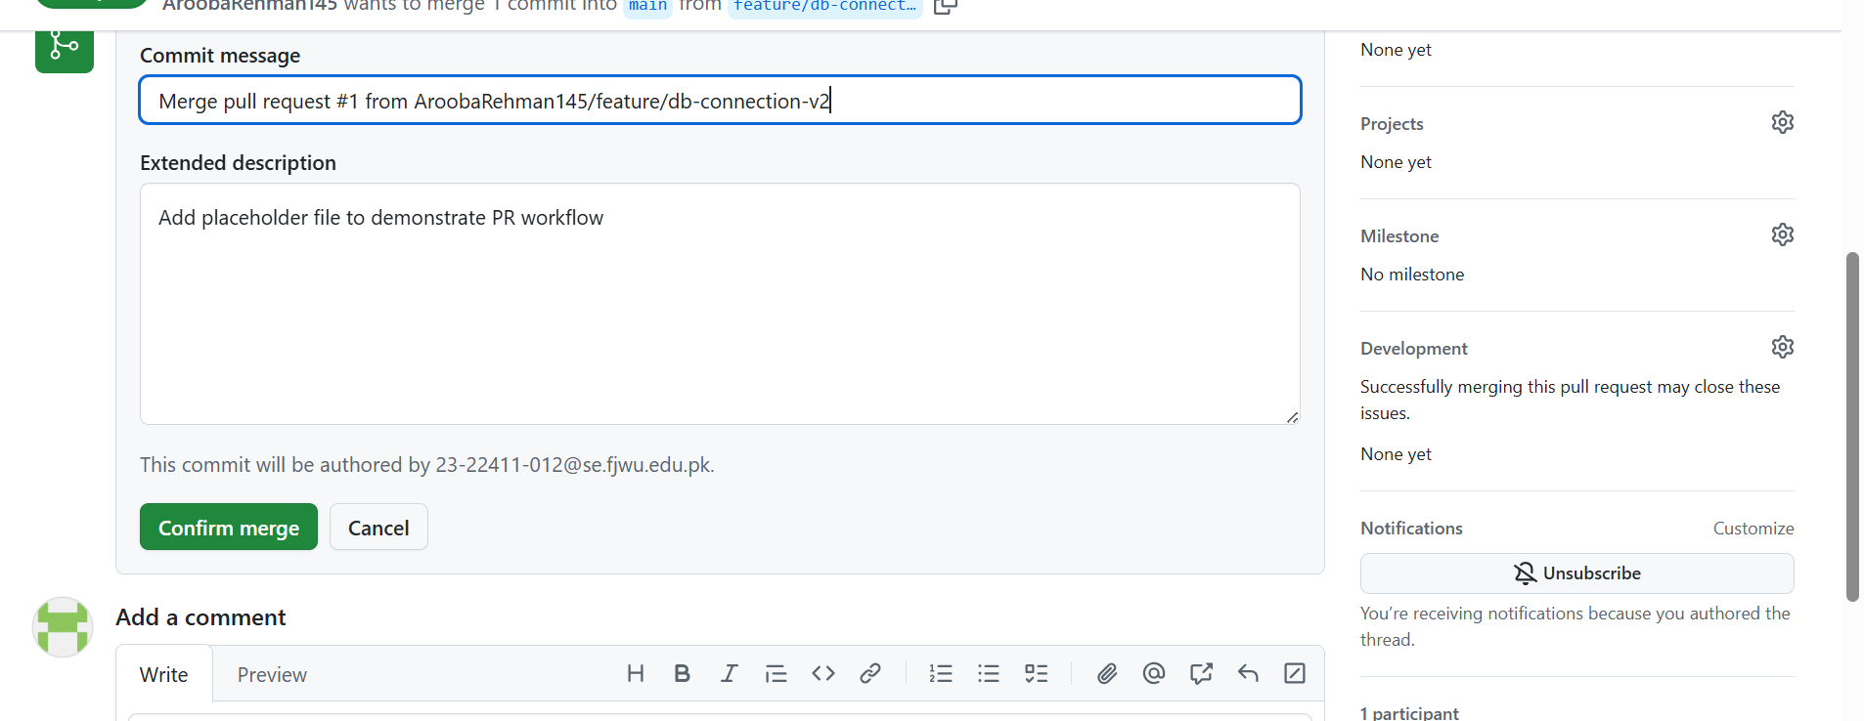

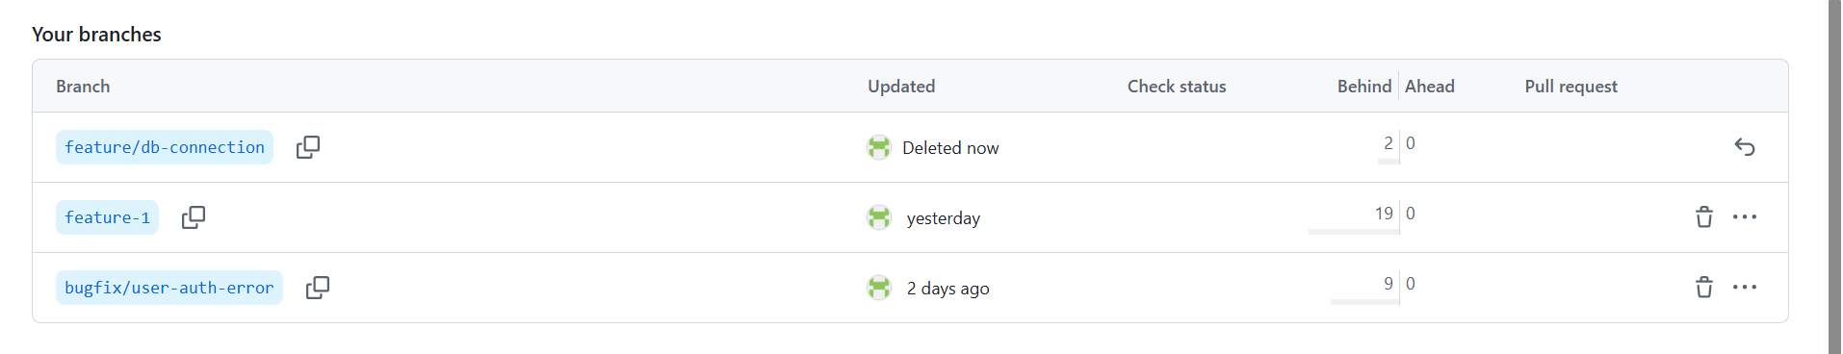

**Task 11**

**Detailed Branch Strategy**

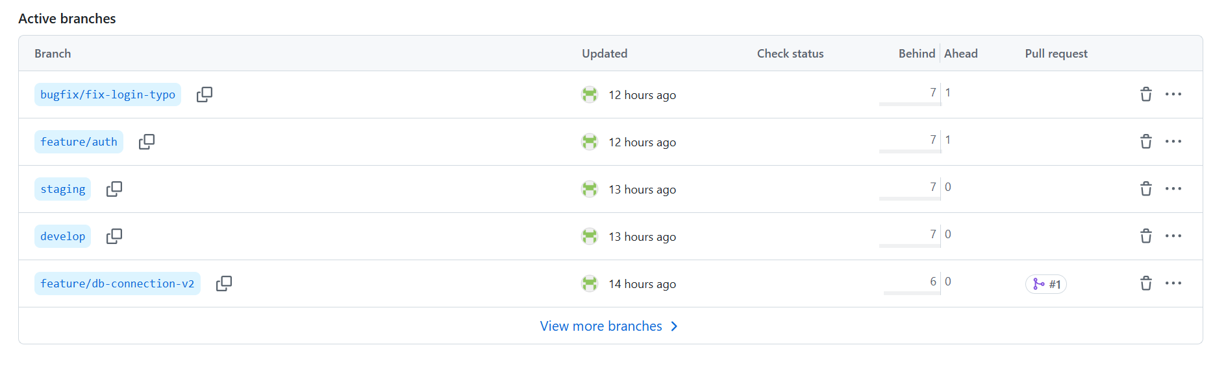

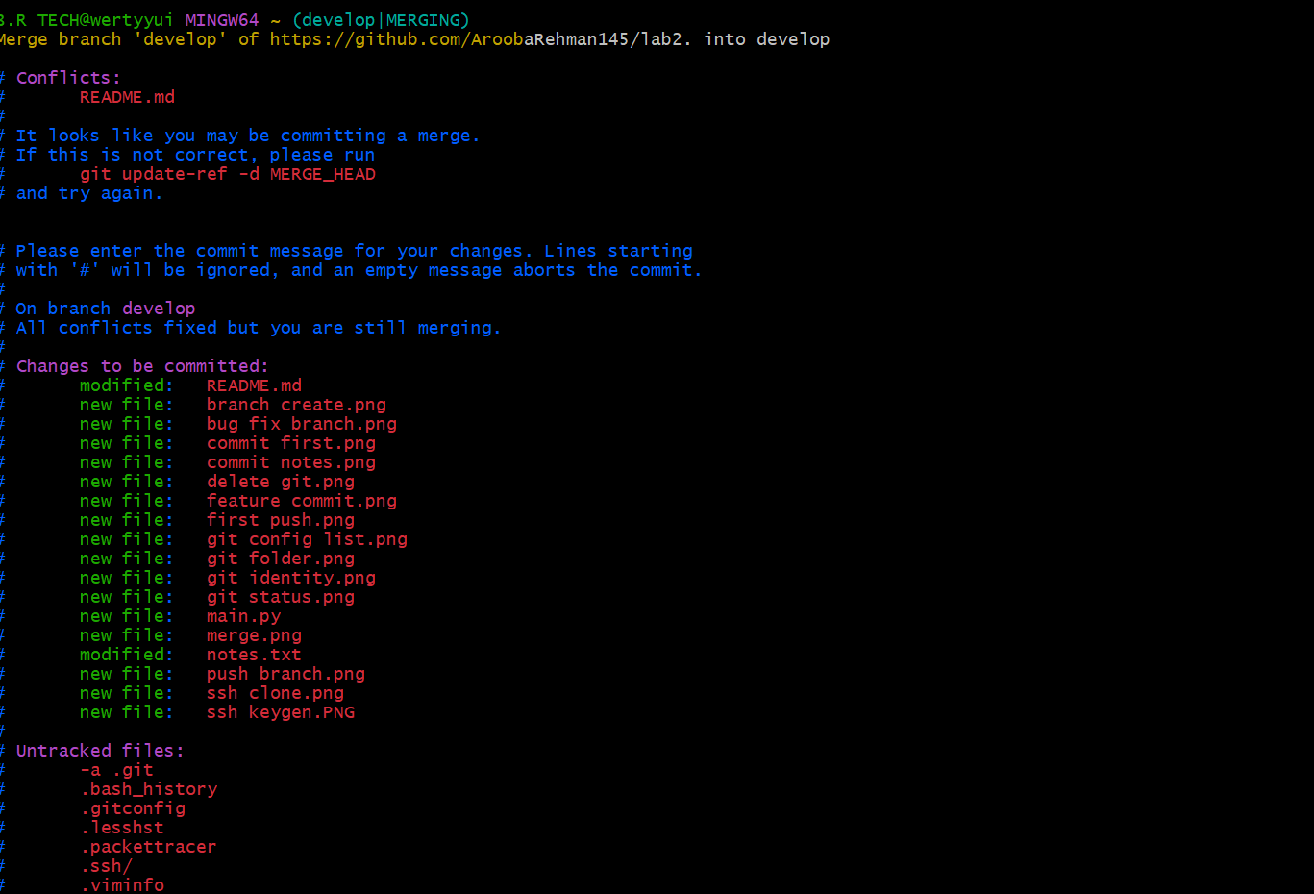

**Task 12**

**Code Review Workflow**

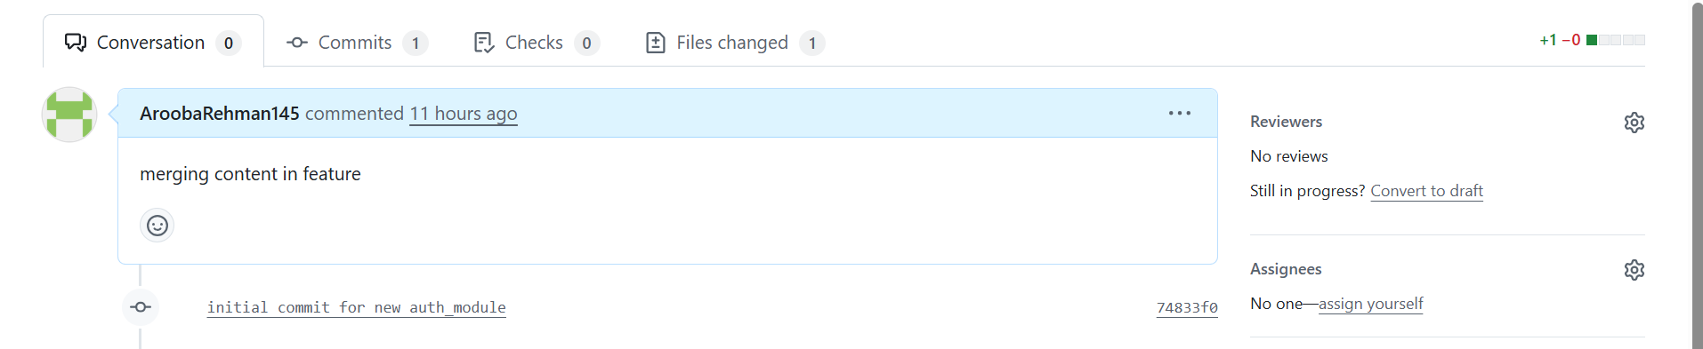

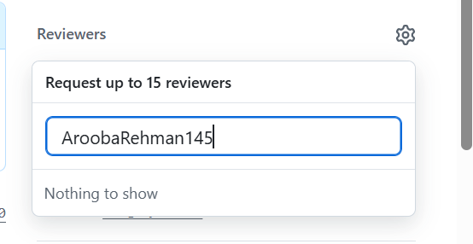

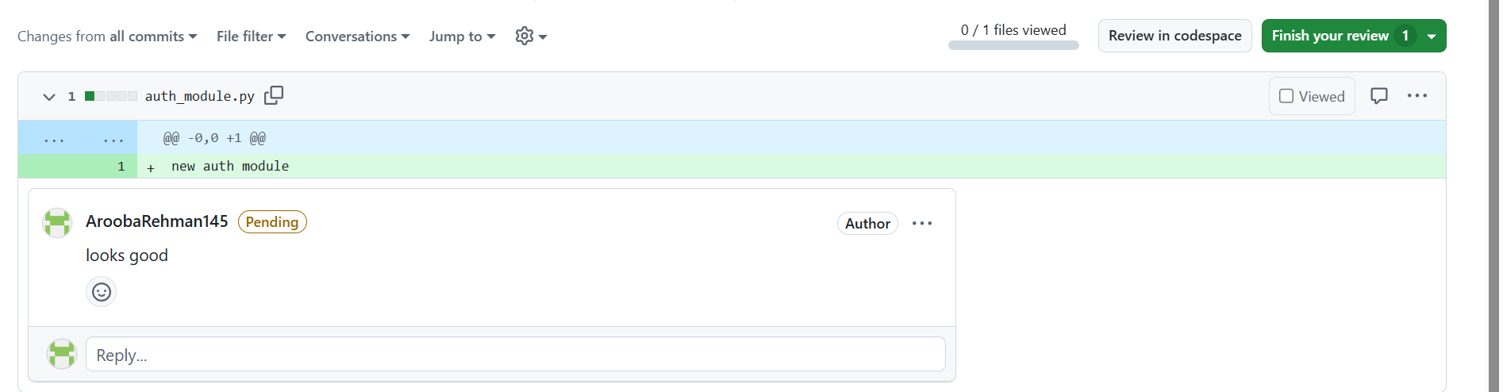

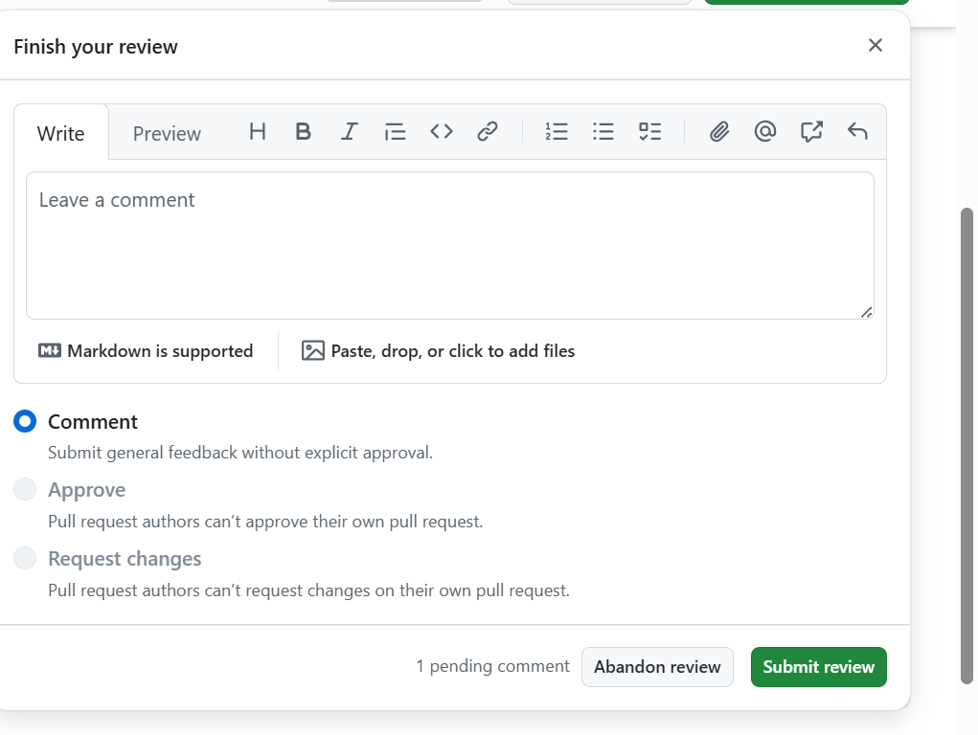

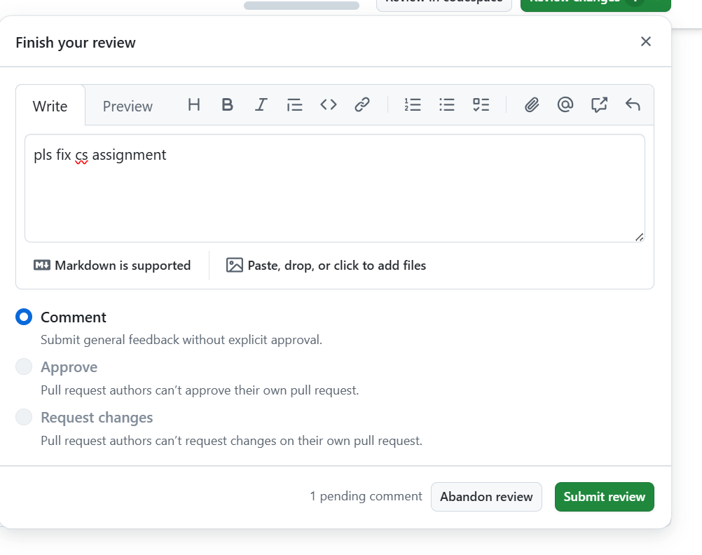

**Task 13**

**Branch Cleanup Best Practices**

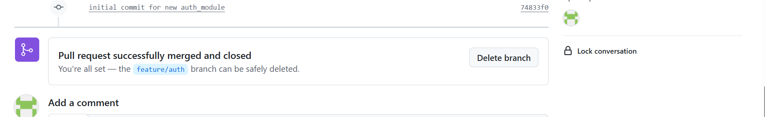

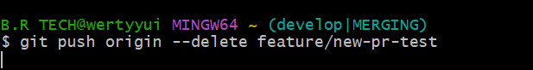

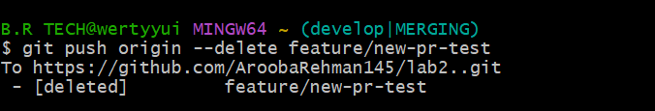

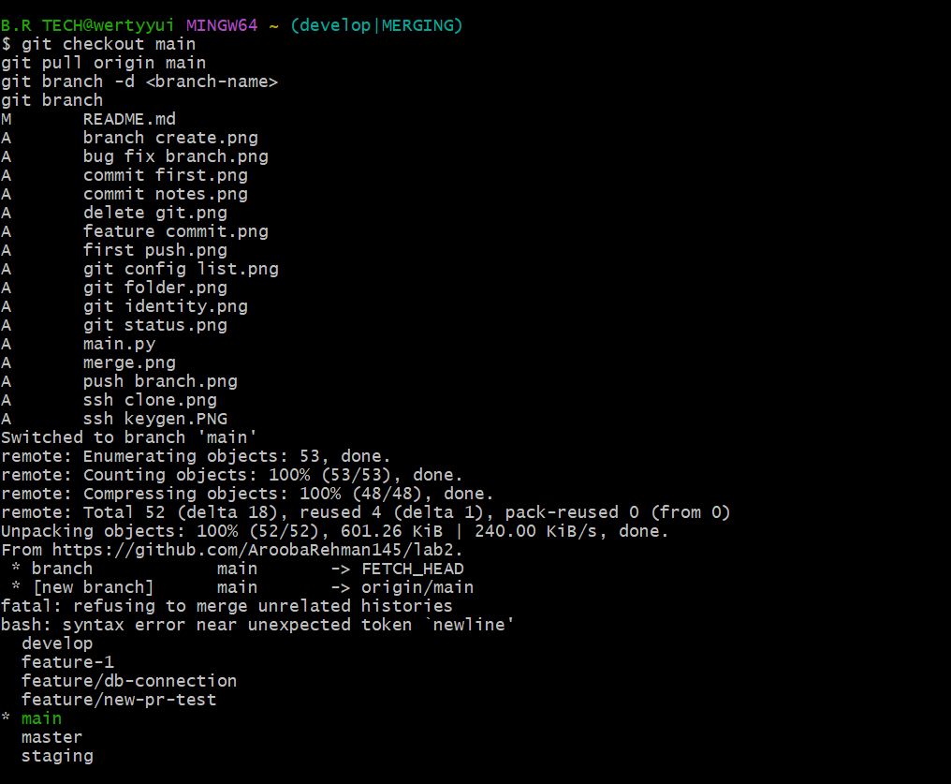

**Bonus Task: Simulated Team Collaboration**

